Academic research staff from Abdelmalek Essaadi University of Tetuan develop thesis at UPCT on Industry 4.0 and Telecommunications
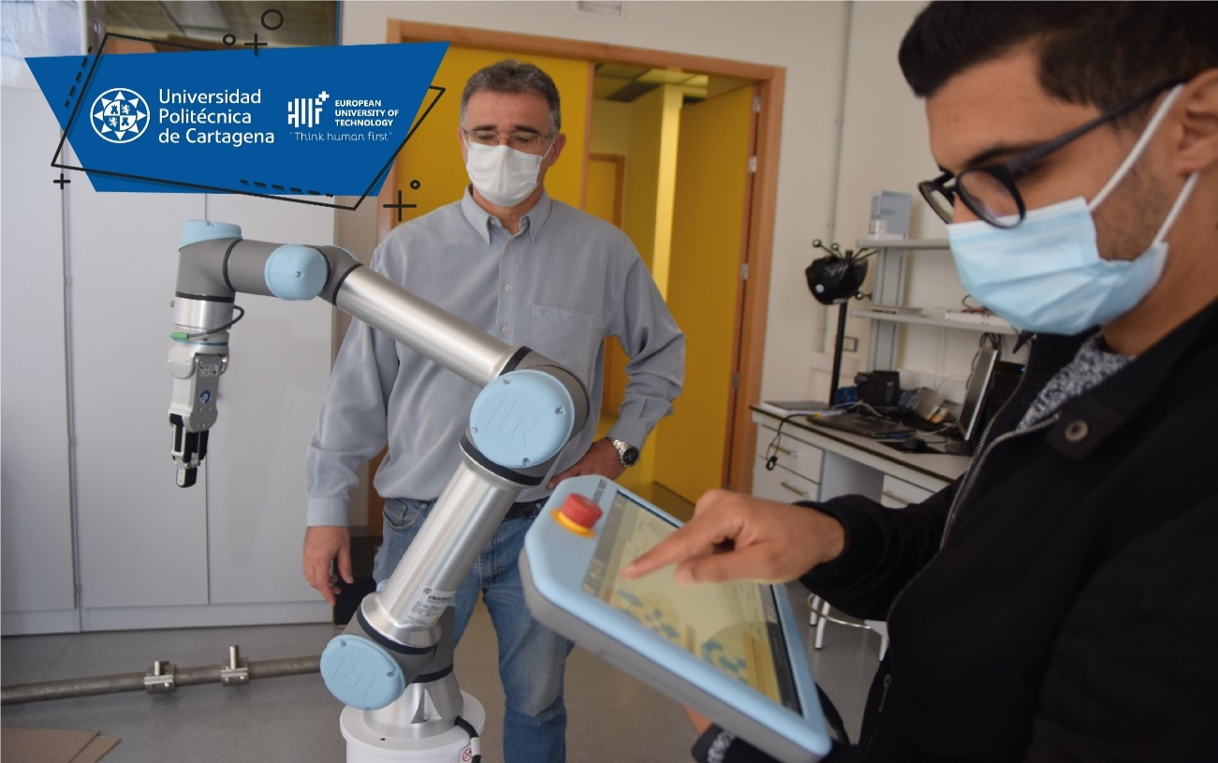
13 foreign doctoral students are carrying out their doctoral research in the UPCT this year. Seven of them come from Moroccan universities.
The fruitful relations between Polytechnic University of Cartagena (UPCT) and Abdelmalek Essaâdi University of Tetuan, the most important in northern Morocco, have enabled two doctoral students, and one more in perspective of this academic institution, to develop their thesis at the UPCT within the framework of a cotutelle doctoral program.
Maroaune Salhaoui is carrying out his thesis, under supervision of Professor Mounir Arioua from Tetuan and professors Antonio Guerrero and Francisco Ortiz from Cartagena, on Smart IoT monitoring and real-time control based on autonomous robots, visual recognition and cloud/edge computing services. The resulting research works are currently published in major journals indexed in Springer, IEEE and MDPI.
"I chose to come to the UPCT because there were opportunities for PhD cotutoring, I also appreciated the work atmosphere here with my professor" says Salhaoui, who has been in Cartagena for three years now, a city of which the calmness is the distinctive characteristic.
Another doctoral student from the same university, Mohamed El khamlichi, is also developing his thesis in the UPCT, in applied Electromagnetism and Telecommunications supervised by Alejandro Álvarez Melcón and Otman El Mrabet from Morocco. His current work resulted in scientific publications and communications at international conferences.
A third PhD student in the group, Yassine Yazid, supervised by Professors Arioua and Ahmed El-Oualkadi, has obtained an Erasmus grant to join UPCT and interested in performing his thesis within a framework of a cotutoring doctoral program, investigating in IoT, Machine Learning and Cloud Computing project that is carried out by Professor Antonio Guerrero.
The professors of both universities, Antonio Guerrero and Mounir Arioua, began to collaborate in 2017 and in 2018 and an agreement was signed to facilitate the cotutelle program. "Our university and UPCT show great interest in mutual collaboration and have created a favorable environment for research and academic cooperation," highlights Arioua.
The cotutelles are doctoral thesis program directed by researchers belonging to different universities and to the UPCT. This year there are 13 foreign doctoral students who carry out their doctoral research under a cotutelle doctoral program. Seven of them are from Moroccan universities, specifically from Tetuan, Casablanca, Rabat and Fez.

